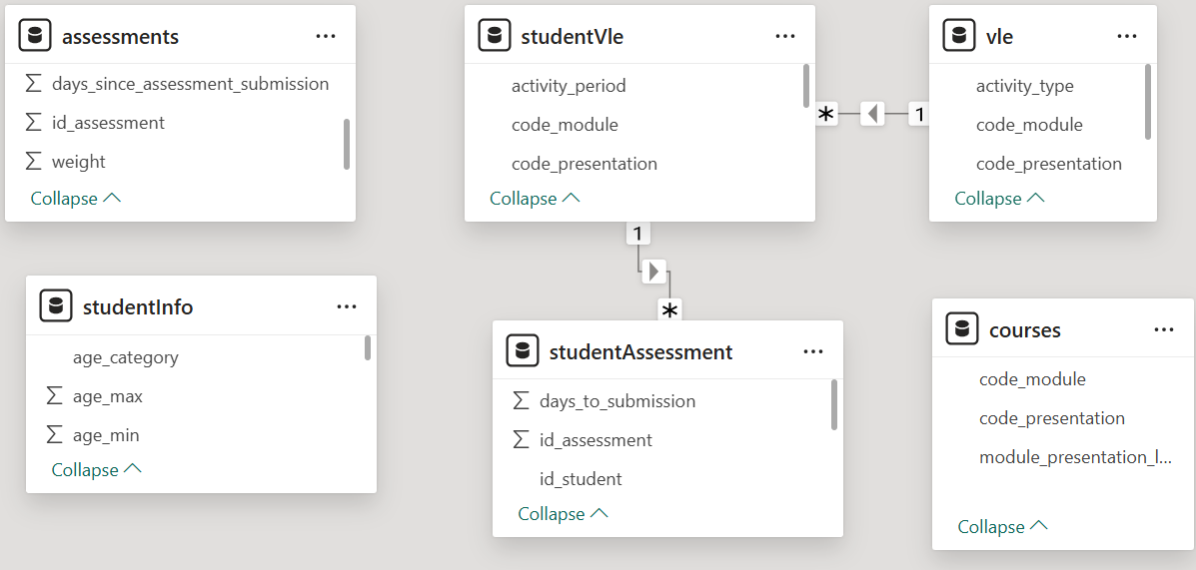
Before
• This shows the initial model before any changes were made.
• At this stage, the tables are not yet well connected or optimized for analysis.

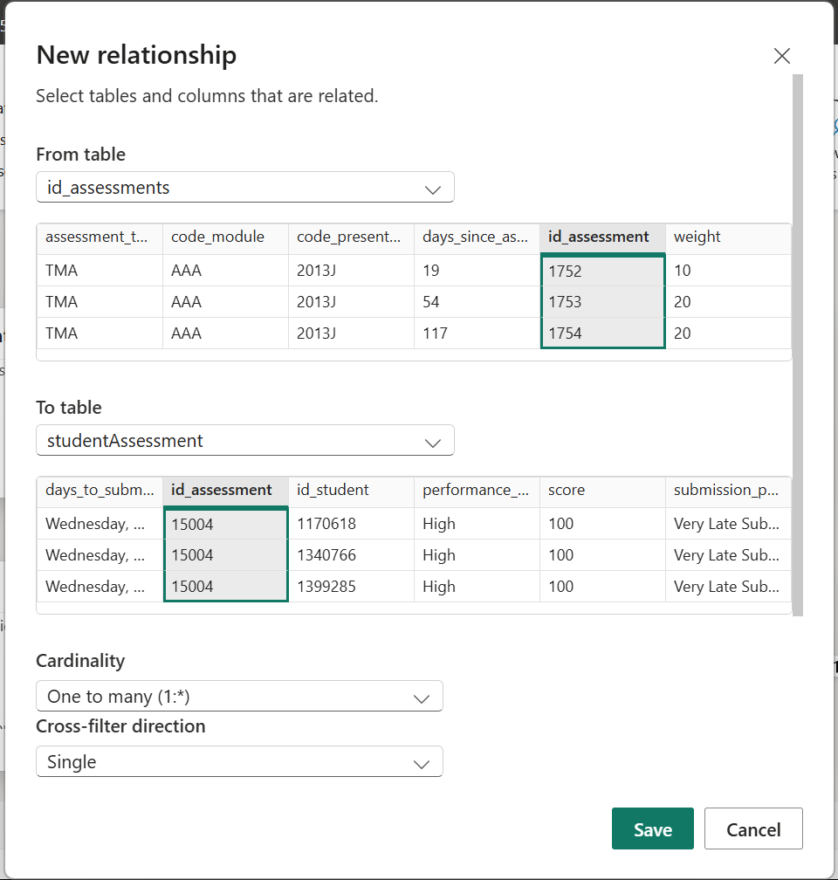
Creating new relationships
• Relationships were added to link the tables together.
• This makes the data easier to work with and ensures more accurate analysis.

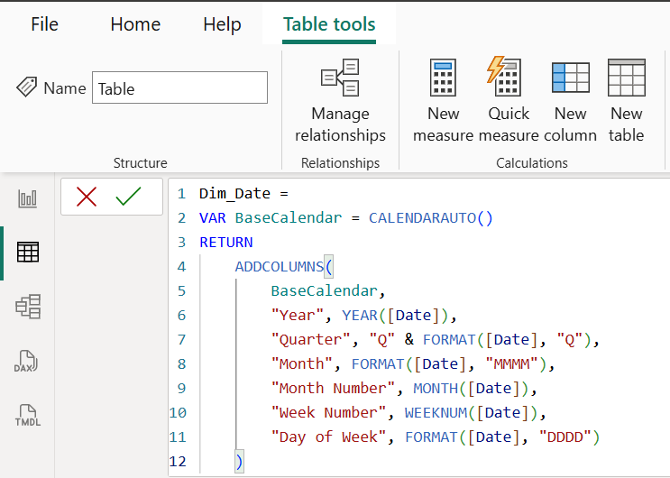
Calculated DAX Table
• A new table was created using DAX formulas.
• This helps organize the data better and supports additional calculations.
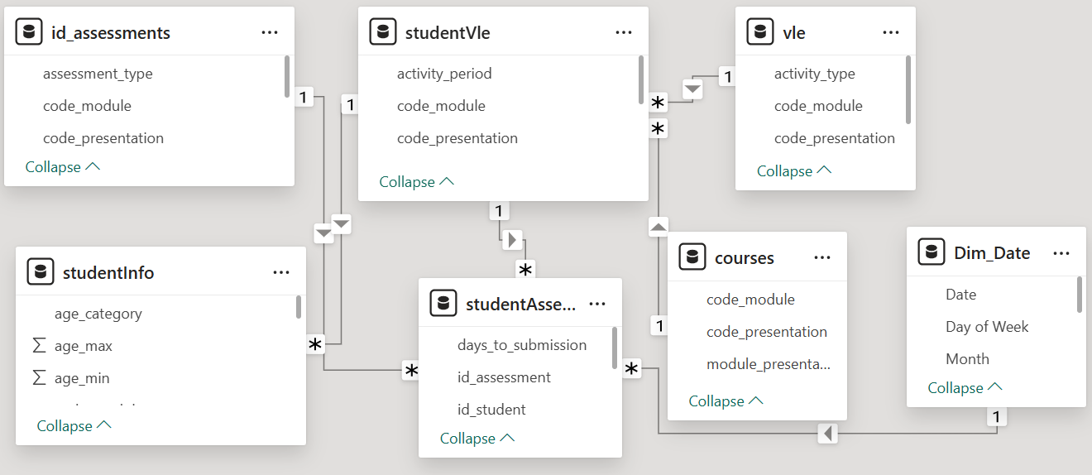
Model View including the newly created DAX Table Dim_Date
• The Dim_Date table was added to handle date-related analysis.
• This makes it easier to analyze trends over time.

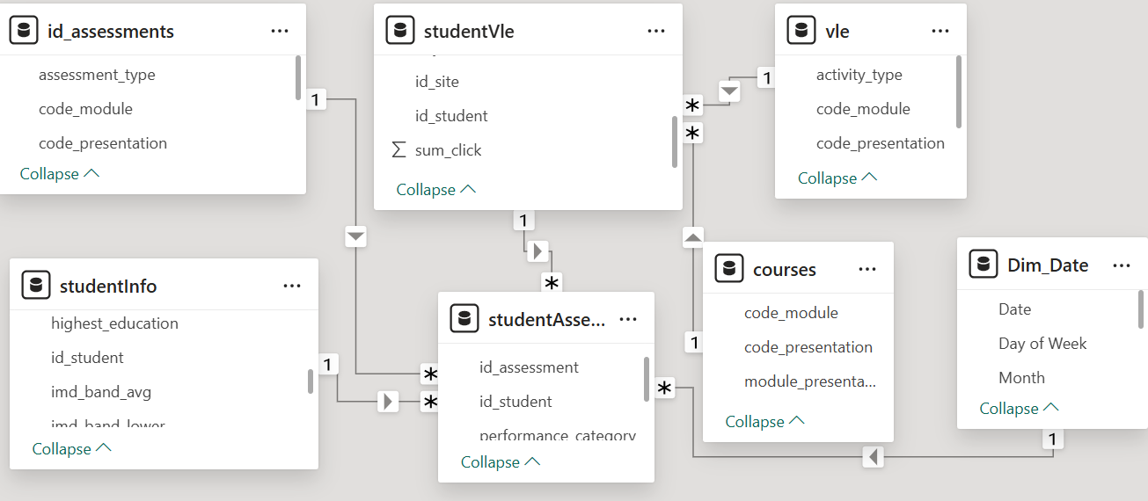

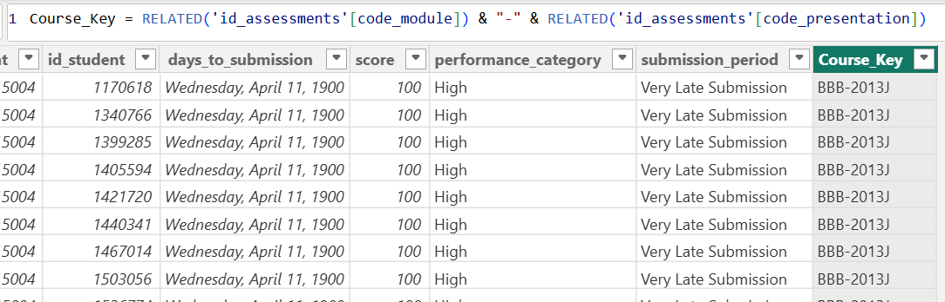
Creating a new column for star schema in the studentAssesment table

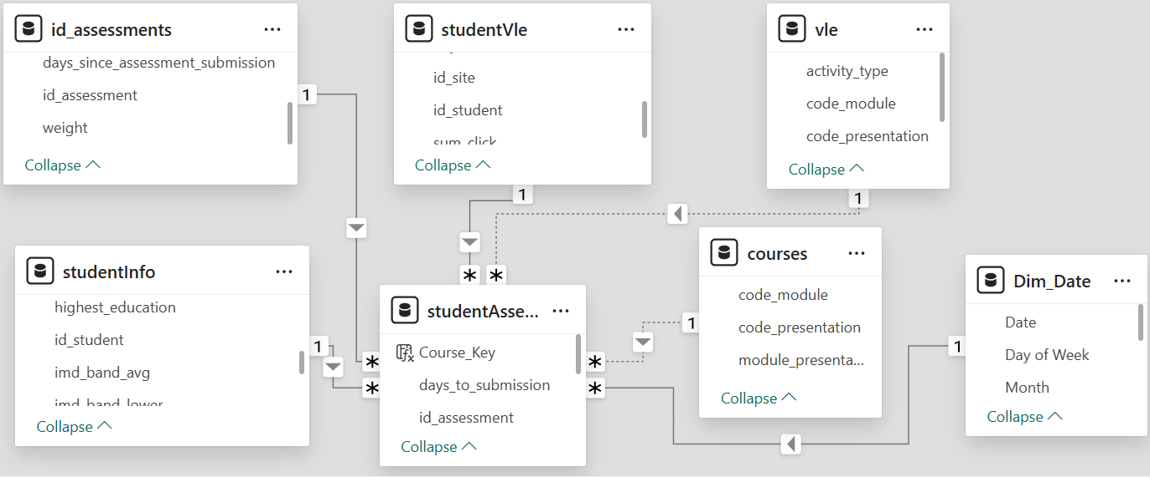
Final model view with the correct cardinality
• The relationships were adjusted to the correct cardinality (one-to-many).
• The model is now clean, well-structured, and ready for accurate reporting.

